How to Build a Website [ from Scratch ] with HTML

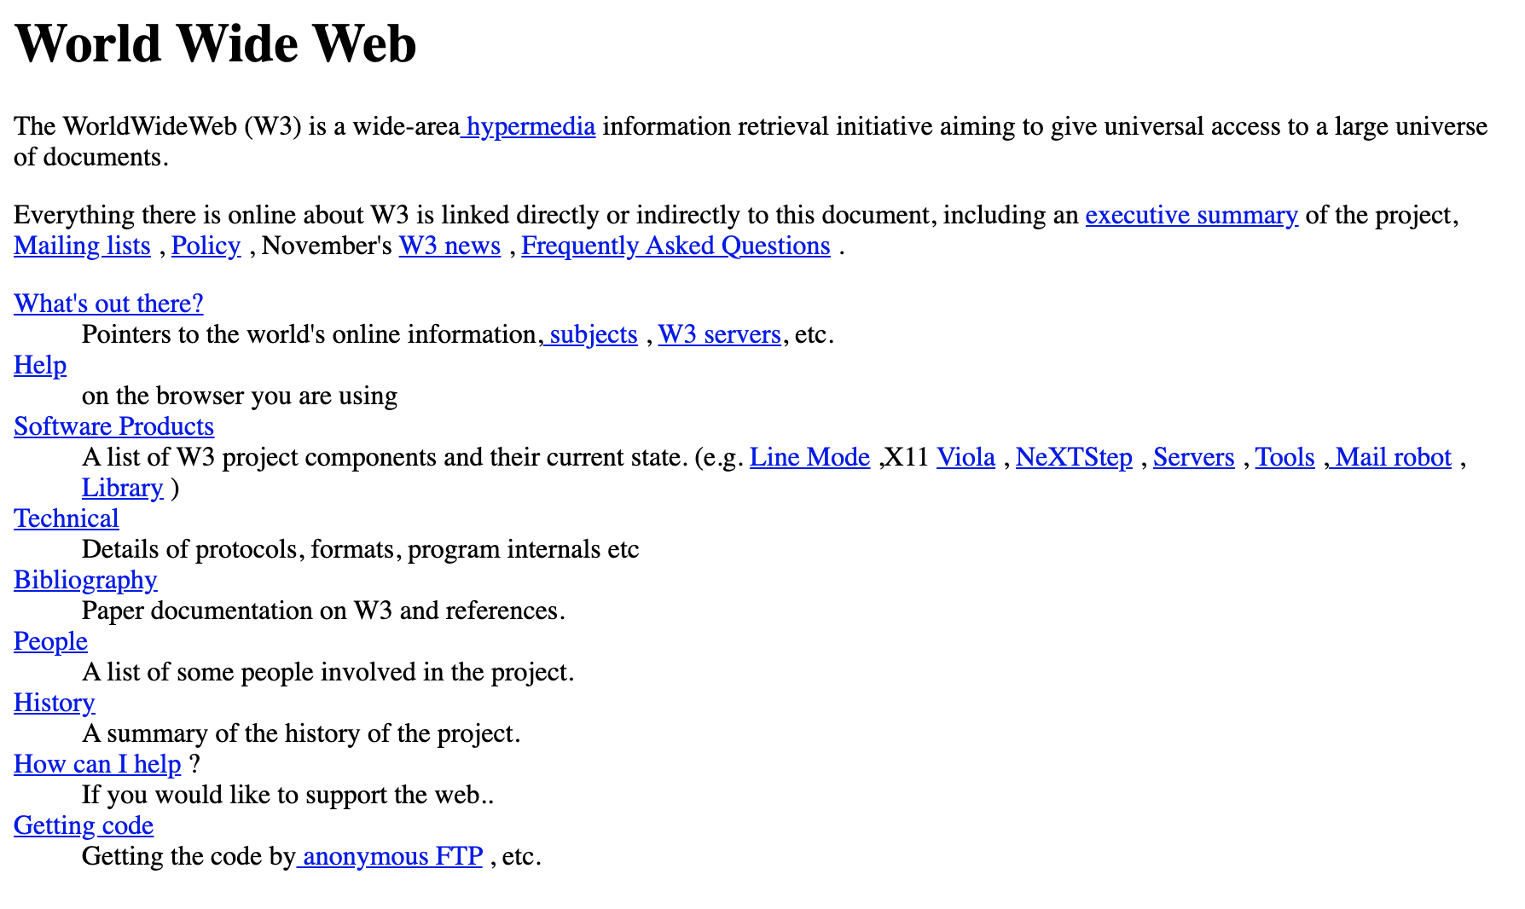

hg

Source: The first website launched by Tim Berners Lee while at CERN on August 6, 1991

Prerequisites

1. Code editor, Visual Studio Code (VS Code), a free code editor available for Mac or Windows
2. Web browser, Google Chrome

Setting Up Your HTML Project with VS Code

1. Open your local GitHub repository in VS Code. You can do this in a couple ways:
2. Click on the “File” menu item in the top menu and scroll down to “Open”. In the Finder window, navigate to your local Github repository. Mine is called cuddly-octo-goggles! Click the blue Open button.  
   
3. In the Get Started window, navigate to the Recent section and click on the name of your local Github repository.  
   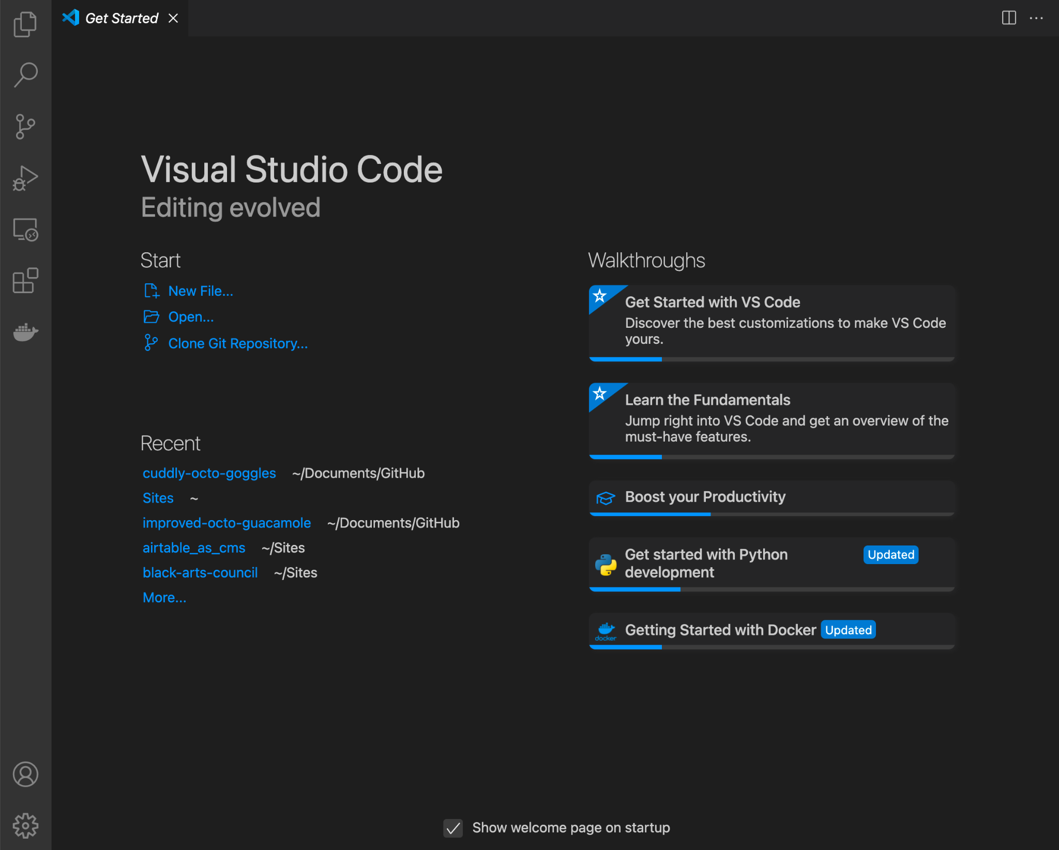
4. Open up a new project folder and name it /exercise-02.   
   To create a new project folder in VS Code, navigate to the “File” menu item in the top menu and select “Add Folder to Workspace.” In the new window, click the “New Folder” button and create a new folder called /exercise-02 as illustrated in the gif below:



1. Next, inside the /exercise-02 folder create a new file called *index.html*
2. You now have a project folder and file for embarking on a new web based project.

Viewing Your Local HTML File in the Web Browser

You can view your local *index.html* file in the Chrome browser a few ways:

1. Drag the *index.html* file from Finder and drop it into your web browser window.
2. CTRL + Left Click (on Mac) or Right Click (on Windows) to open the *index.html* file in the browser  
   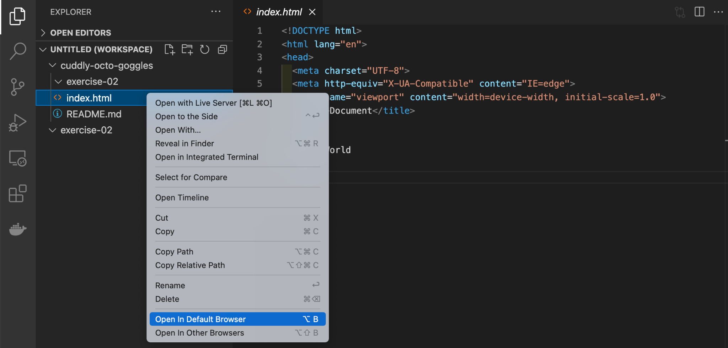
3. Copy the full path of your file and paste it into the browser address bar. CTRL + Left Click (on Mac) or Right Click (on Windows) on the *index.html* file in the panel on the left and select “Copy Path”. Then, paste the path in the web browser.  
   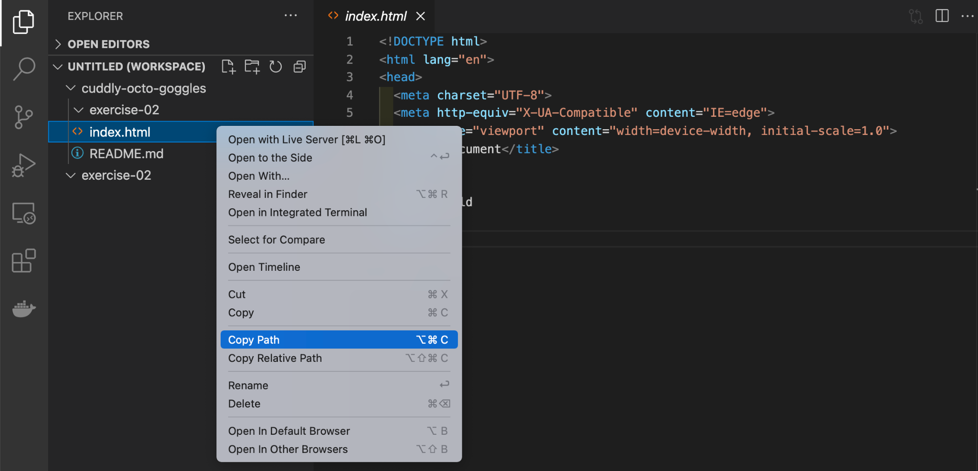

Note: refresh the browser window as you build out your website to see the changes you make locally in your GitHub repository.